Design
App Layout
This app can be broken down into a few key components. I will develop these sections to work individually then combine them together to make the app. These components are as follows:

- Home:
  - This screen will be the landing tab the user will see when they open the app.
    - This screen will contain the study features of the app such as the to do list and Timer.
    - Player will be at bottom with song/playlist in same position as when app was closed.
    - Button to scan for audio files and settings button will be at top along with a search bar to search for songs.
    - Tabs for other menus such as music finder, playlists, tracks, favourites
- Settings:
  - This screen will be where the user can change various options in the app.
    - Will be split into various sections each relating to different sections of the app (Apperance, downloads).
- Playlists:
  - This screen will be where users can see their playlists.
    - Contains button to create a new playlist at the top.
    - Shows all playlists in alphabetical order along with runtime and number of songs.
    - Clicking on a playlist brings up all the songs in said playlist, each stating its name and duration.
    - Holding and dragging a song will rearrange its position in the playlist.
    - Buttons to play/shuffle playlist or add/remove songs at the top.
- Tracks:
  - This screen will be where users can see their downloaded tracks
    - Acts similar to Playlists screen but will show all tracks downloaded rather than separating into smaller custom playlists

- Music Finder:
  - This will be further broken down into search and download.
  - Search:
    - User inputs a search query in search bar at the top of the screen.
    - Program then brings up a list of up to 25 relevant search results.
    - Search bar will still be at the top of the screen in case user wants to search something else.
    - If no results found or unable to perform search then an error message will be displayed.
  - Download:
    - On the search result there will be a button user presses to trigger a download. Download will start in the background. Progress can be seen in downloads tab. Once downloaded, relevant file info will be uploaded to SQLite database.

- Player:
  - This screen will be where users can control the player.
    - It will show the progress through the song, song name and player control options like shuffle, loop, play/pause, skip song/go back song.
    - Button which the brings up player song queue.

- Favourites:
  - This screen will be where users can see their favourited tracks
    - Acts similar to Tracks screen but will show all downloaded tracks which have been favourited rather than just showing every track downloaded.

App Visualisation
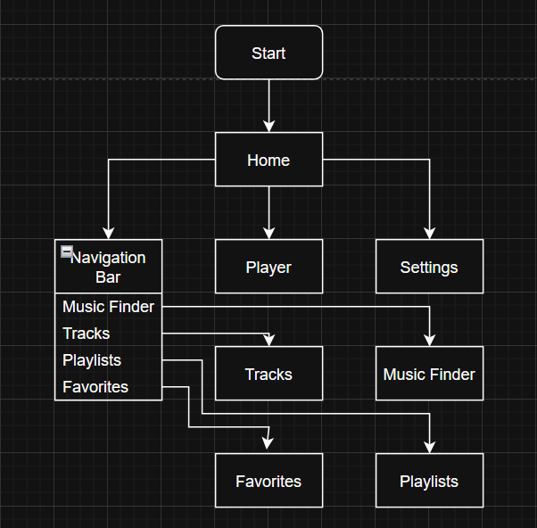
This flowchart demonstrates how the structure of the app will work. The app will open up to the home page giving the user direct access to the player, the settings and the navigation bar.

From there, a large majority of the time the user can just click on the player’s play icon at the bottom of the screen and start playing their playlist. If they need to access something else they will be able to normally find it on the navigation bar.
At anytime the user will be able to quickly navigate back to the home menu through the navigation bar as all the links are 2 way.

Database Structure
For my program to work, I need to store data locally so it is easily and quickly retrievable. I will do this in an organised back-end database to prevent redundancy and allow ease of usage to program / use to query. Below is my database structure
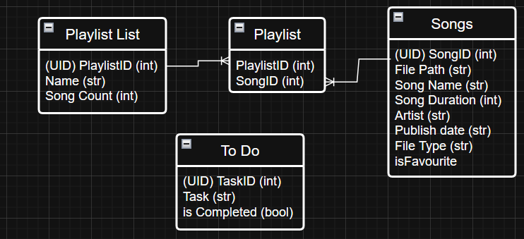
The tables “Playlist List”, “Playlist” and “Songs” are all for managing the users playlists Playlist is used as a bridging table to prevent a many to many relationship by creating 2 one to many relationships. The “To Do” table is not connected to the others as it is in a separate system to the others but will be a table in the database.
Home Screen
This page will be the screen they see when they open the app. It will hold the timer and the to do list so users can quickly access them when opening the app. The player can also be accessed at the bottom through clicking on the full screen button on the player. Users will also be able to scan for their audio files automatically here.

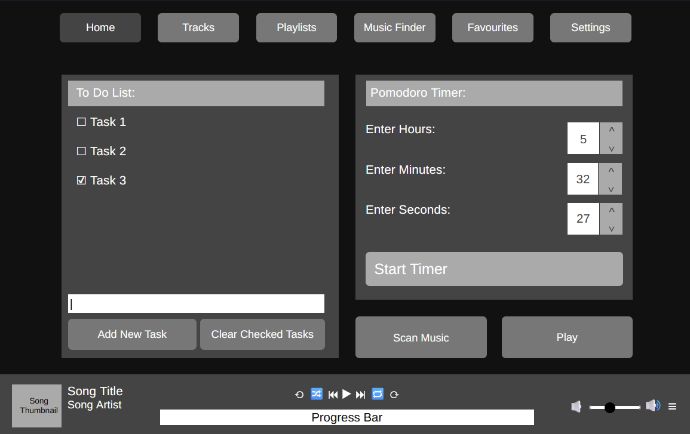
Home Screen Layout
Spinbox widget so user can enter time and limits number entered.
Each button opens a different section of the app depending on what button the user presses.
Current section highlighted so user can teel where they are.
Creates a separate window with the running timer.
Toggles the play/pause state of the song playing.
Progress Bar widget showing how far though the song user is.
Buttons which can modify playback. Buttons explained in player section.
Current playing song details shown here.
Checkboxes so user can tick off tasks as they complete them.
Button deletes checked tasks from database.
Button adds task typed in entry widget to the to do list.
Entry widget so user can enter their task.

Volume slider to adjust volume and queue button to access the queue. Explained in player section.

Because the home screen has multiple features which will be using their own algorithms I will be further splitting it up into the To Do list, timer and Scan Music subsections. The player will be explained in a later section as it will be constantly present to the user.

To Do List
The to do list lets users track their current tasks as they need to. Initially any tasks in the to do database are retrieved and displayed as checkbox labels. If the user enters text in the entry widget and submits it is added to the to do list. If the user checks off tasks and clears them they are removed from the to do list and database. There are 2 algorithms this to do list will use one to add tasks and one to remove tasks.

This is the database the To Do list will use to store and access data.
Field Name | Data Type | Description | Primary Key?
TaskID | integer | Uniquely identifies each task in the database so 2 tasks can be the same and have the same completion status . | Yes
Task | string | Holds the description of the actual task. | No
Is_completed | boolean | Holds the current status of the task so program knows whether to have checkbox marked or not. | No
Add Task Algorithm
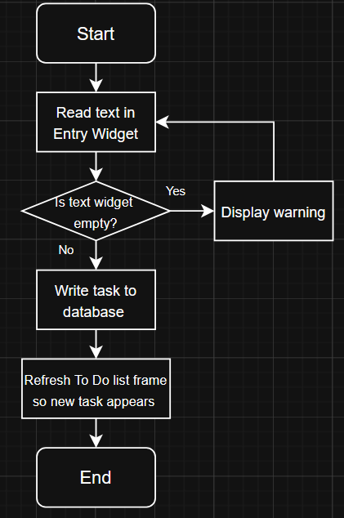
Add Task Variables
Remove Task Algorithm
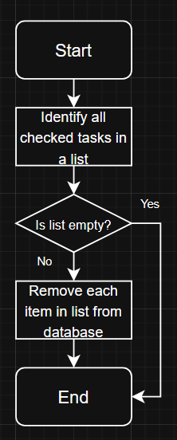
In this case no error is thrown at the user if the list is empty as this step exists more to not have to unnecessarily query the database rather than having no checked items causing issues.
Remove Task Variables

Timer:
The timer will be fairly simple and allow the user to input the number of hours minutes and seconds they want into a spin box widget.
Once the user presses start timer the hours, minutes and seconds are taken and turned into a singular integer number holding the total number of seconds remaining. Each second the seconds remaining are reduced by 1 and the time is converted into hours, minutes and seconds for display purposes. Once the timer finishes the user’s music is paused and an alarm sound plays to notify the user that their time is up.
The timer will also have buttons to pause and reset the timer. The reset timer will work by setting remaining time equal to the starting time. This will automatically also update the displayed time. The pause time will stop the subtracting of 1 from the remaining time every second whilst the timer is paused. When paused the icon in the button will also change. The timer position will not be held in storage so timer progress will be lost if the program is closed.
Running Timer Pop Out Window
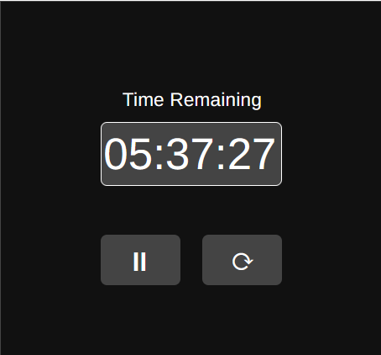
Timer Algorithm
Timer Variables

Scan Music
The scan music button will scan the users files to try find audio files which the user wants to listen to.
Scan Music Algorithm
Scan Music Variables

Tracks
This section of the app will be where users can see all their downloaded songs the app has identified. The songs will be listed alphabetically by default. At the top the number of songs will be shown as well. Next to it there will be a button to allow users to multi select songs so they can easily mass add songs to playlists.

Database
This section uses the 3 tables “Songs”, “Playlist” and “Playlist List” which are described below.
Songs
Field Name | Data Type | Description | Primary Key?
SongID | Integer | Used to uniquely identify a song in the database | Yes
File_path | String | Used to find where a song is in the file directory | No
Song_name | String | Used to quickly find the name of the song | No
Song_duration | Integer | Used to find the length of a song in seconds. Can be then converted to mins and secs | No
Artist | String | Used to quickly find the person who published the song. | No
Publish Date | String | Used to quickly find when the song was posted. | No
File Type | String | Used to identify is the song can be played in the app. As some file | No
isFavourite | boolean | Marks if a song is favourited or not | No
Playlist
Field Name | Data Type | Description | Primary Key?
SongID | Integer | Used to uniquely identify a song in the database | No
PlaylistID | Integer | Used to uniquely identify a playlist in the database | No

Playlist List
Field Name | Data Type | Description | Primary Key?
PlaylistID | Integer | Used to uniquely identify an individual playlist in the database | Yes
Name | String | Name given to playlist which user chooses for memorability. | No

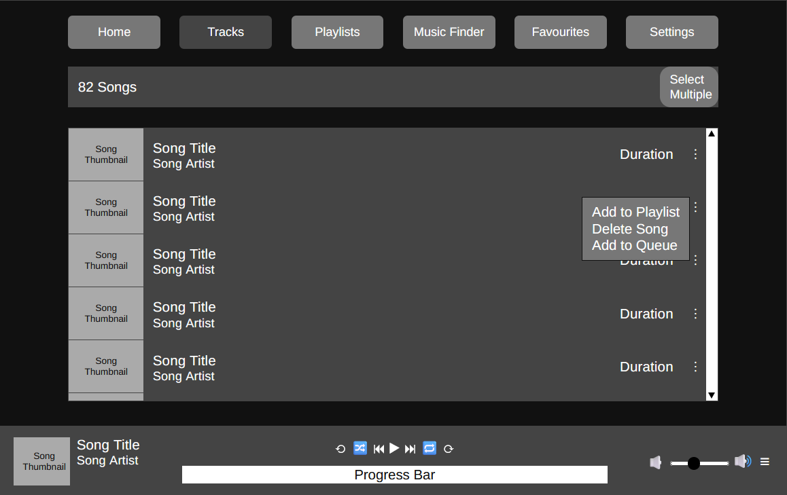
Tracks Screen
Scroll bar so user can see songs which don’t fit.
Checkbox list displayed so users can select multiple son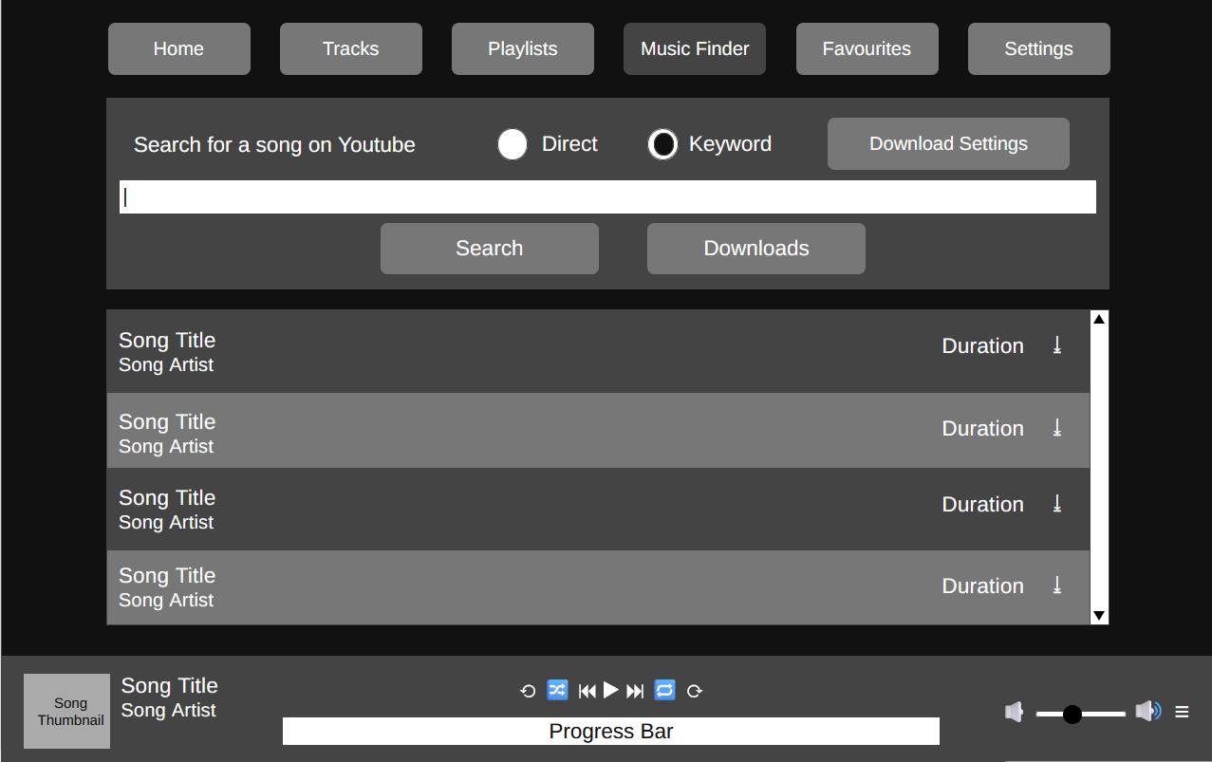gs at once.
Popup menu so users can interact with a song. Accessed through 3 dots.
Duration so user can see how long a song is quickly.
Song picture, name and artist shown for songs.
Total number of songs listed

The select multiple button modifies the frame where all the songs are listed to make them into checkbox labels. This will be where the user can find their songs to put them in playlists. There are 2 ways of doing this. Adding each song individually through 3 dots or multi selecting songs and mass adding them to playlists. To delete songs from one is a similar process. The “Delete Song” option deletes the song from database and no longer appears until rescanned.
Select Multiple Screen
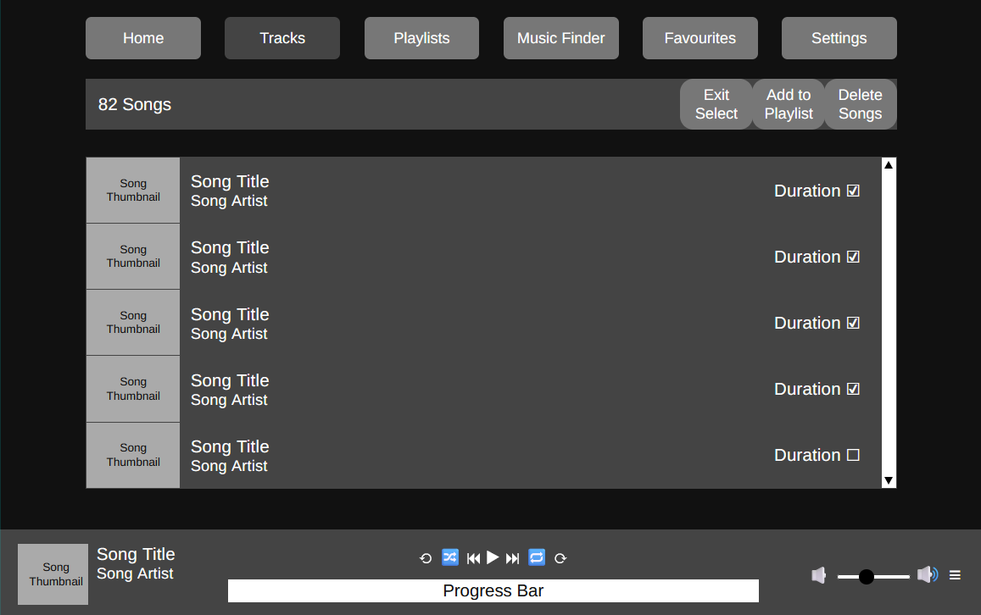
Add to playlist
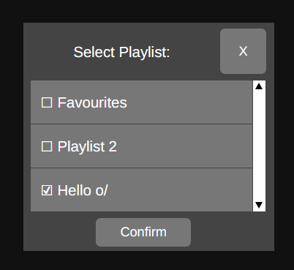
This menu will appear as a separate window where the user can select multiple playlists and have the selected song(s) held in that playlist. For this screen we need to be able to access 3 tables in out database. “Playlist”, “Playlist List” and “Songs”. As we need to be able to retrieve the names of each playlist which is done through Playlist List and we need to add the songs to each selected playlist which is done through Playlist. Songs is used to get the SongID of each song which needs to be added to the playlist.

Playlists
This portion of the app will let users see and interact with their playlists, create new ones and delete current ones. It will have a layout similar to Tracks but it will first show the user all their playlists (favourites is classed as playlist) and then they can select one playlist and then further interact with it. The popup menu triggered by the 3 dots also has slightly different options and the top bar now also has a button for users to create a playlist.
Databases
This portion of the program utilises 3 tables in the database “Songs”, “Playlist” and “Playlist List”.
Playlists Screen
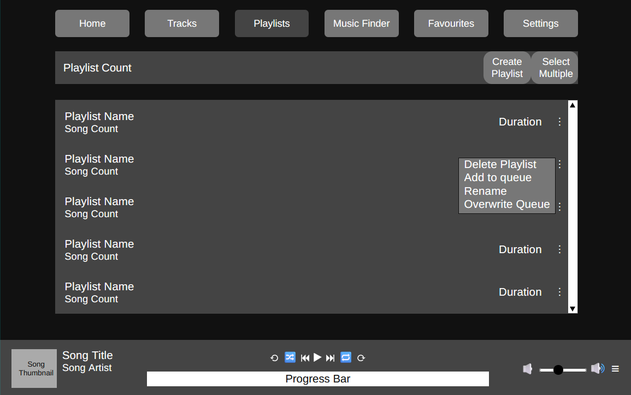

The overwrite queue option clears the queue and adds all songs in the playlist to the queue. It will also check if the user has enabled shuffle for the player. If they have the playlist will be copied and shuffled before overwriting the queue. The add to queue option appends all songs in the playlist to the end of the queue and shuffled if enabled. Delete Playlist deletes the records of the playlist from the database.
Create Playlists Popup Screen
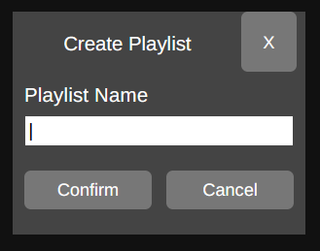
A similar Popup Screen also appears if the user selects the rename option in the popup screen.
Specific Playlist Selected Screen
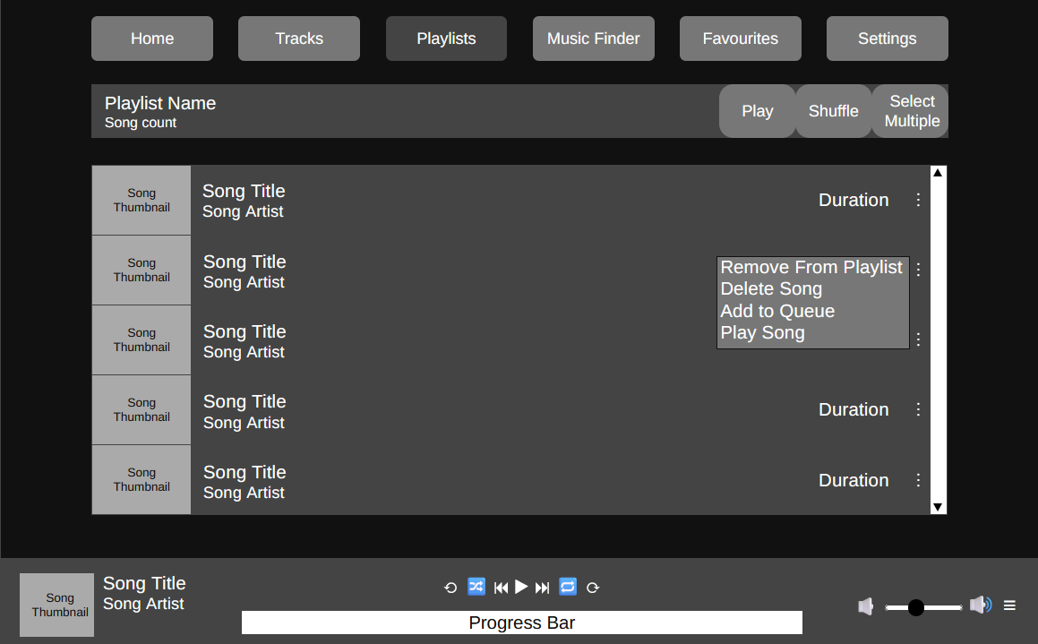

Music Finder
This portion of the app will search for and allow users to search for and download music from within the app. This section can be broken down into 2 sections which happen one after the other. The search portion and the download portion.
In the search portion the user will select their search mode. The first is “Direct” where the user can paste in the URL into the search box and search it which will then automatically trigger a download if one is possible. The second is “Keyword” where the user can enter keywords like “Taylor Swift” and have related songs appear for the user to then select from.
In the download portion the config is read, parsed and then passed onto the YTdl object which then downloads the song.

Databases
This section of the app will interact with one of the tables in the database “Songs” so it can add new songs which have been downloaded to the database.

Search Window
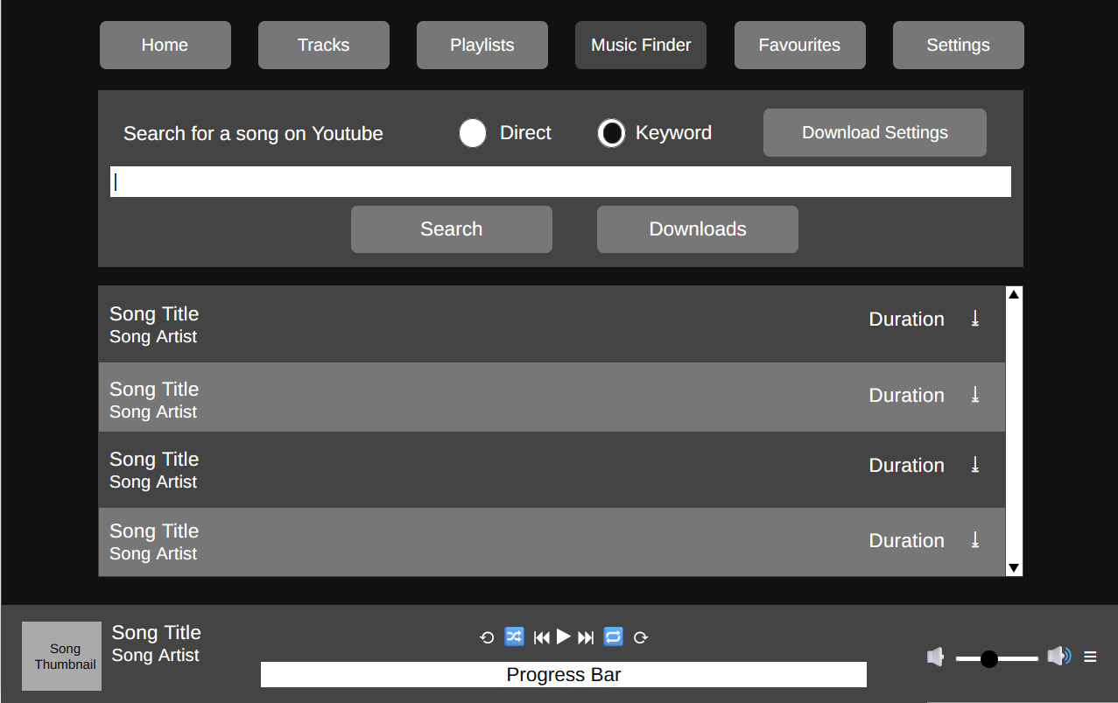
Opens download settings to access download config
Radio button allowing user to select search mode
Clicking on a song starts download for it
Text input so user can enter their search query
Opens a menu where download progress shown

This will the main screen for the Music Finder screen. The lower frame with the songs listed will only appear once the user enters a successful search in keyword mode. If an error occurs when searching such as no internet when downloading a system default error screen which looks like this in windows 11.
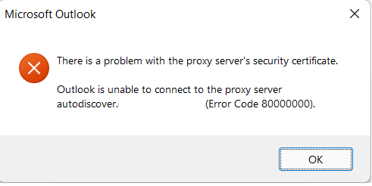

Search Algorithm
The search mostly only just sends requests to YouTube to tell it what to display as the catalogue of available songs to download is any videos available to watch on YouTube. It will run whenever the user attempts to search for a song to download.
It has 2 modes a direct search which bypasses the entire search and gets directly sent to the downloading portion of the program. This is more useful for downloading playlists or unlisted videos which won’t show up on the regular search.
The other mode is keyword which is the default and how a user would normally search for something as they would not have the URL memorised.
Once a query is sent from the user it is put into an API request to YouTube which will then return a list of the top 25 results from the search in a JSON format. This response is then cleaned for anything that is not a video such as channel pages and channel posts as these are unnecessary to the user.
The cleaned response is then parsed through with each item then being displayed nicely by the program. The user can then click on a song to start downloading it.

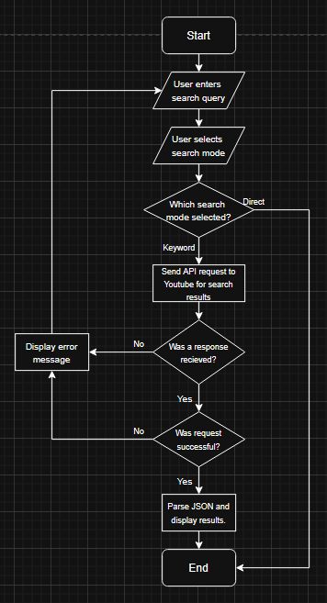

Search Algorithm Pseudocode:
def search(search_mode, search_query):
# Both gathered out of function from buttons / text box

# Checking if user wanted to directly download
if search_mode == “direct”:
download(search_query)
display(“Download started. Check downloads.”)

# User did not want to directly download therefore searching.
# First we are sending a query to YouTube to get a search result
try:
response = send_query(search_query)
except Error as err:
# Response failed to send. Error message is to be displayed.
display(err)

# If except block not triggered then response successfully sent.
# Checking if YouTube declined request
if response == “bad Request 400”:
# Youtube Declined Request but did receive it. Reason displayed
display(response)

# Response successful so we clean out any unnecessary values.
results = clean_response(response)

# Cleaned response then displayed nicely.
display(results)

Search Variable Explanation
Variable Name | Type | Description | Justification

Download Progress Screen
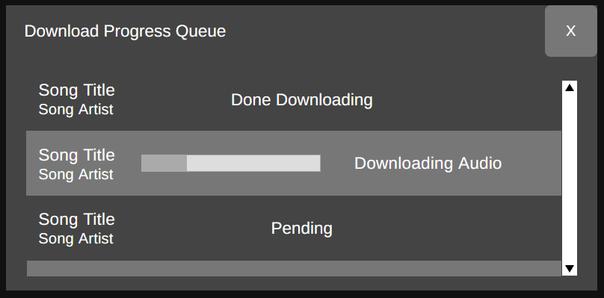
Download Algorithm
This part of the program activates once the user clicks on a song to download it. Once the user clicks on the song, first the program gets the video code if the user is finding a song via keyword search or it directly takes the URL if using direct search. Then, it calls a function which will get the users configuration settings for downloading songs from a SQLite database and put it all into a dictionary. Then the yt-dlp module’s download function will be called to download the requested songs. If any errors occur they will *
The songs will be downloaded to a temporary folder to prevent partially completed downloads from cluttering the target download folder. Once the download is completed the metadata such as artist, track length, song name, etc will be read from the file and put into a SQLite database so database creation is easier afterwards the downloaded file is sent to the folder specified in the user’s config. If the folder does not exist the file will remain in the temp folder and an error message will be thrown to notify the user that the download was successful but the file remains in the temp folder and that they should move it themselves.
Below is a flowchart showcasing how the algorithm will work.
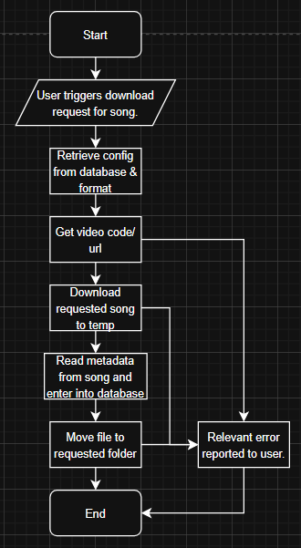
Below is the pseudocode showing specifically how this algorithm will work.

Download Algorithm Pseudocode:
def download_song(song_url):
try:
config = retrieve_config()
downloader = yt_dlp.YoutubeDL(config)
downloader.download(song_url)
store_metadata()
move_song_files()
except exception as err:
display(err)
Download Variable Explanation
Variable Name | Type | Description | Justification

Favourites
The favourites section of the app is mostly similar to the Playlists section except the Favourites playlist is automatically opened on this screen. A song is marked as a favourite by adding it to the favourite playlist or clicking the heart icon when it is playing. The favourites playlist cannot be deleted. Attempting to do so will unfavourite all songs in the playlist.
Databases
This portion of the program utilises 2 tables in the database “Songs” and “Playlist”. Playlist List is not necessary as only songs from the “favourites” playlist will be shown.
Favourites Screen
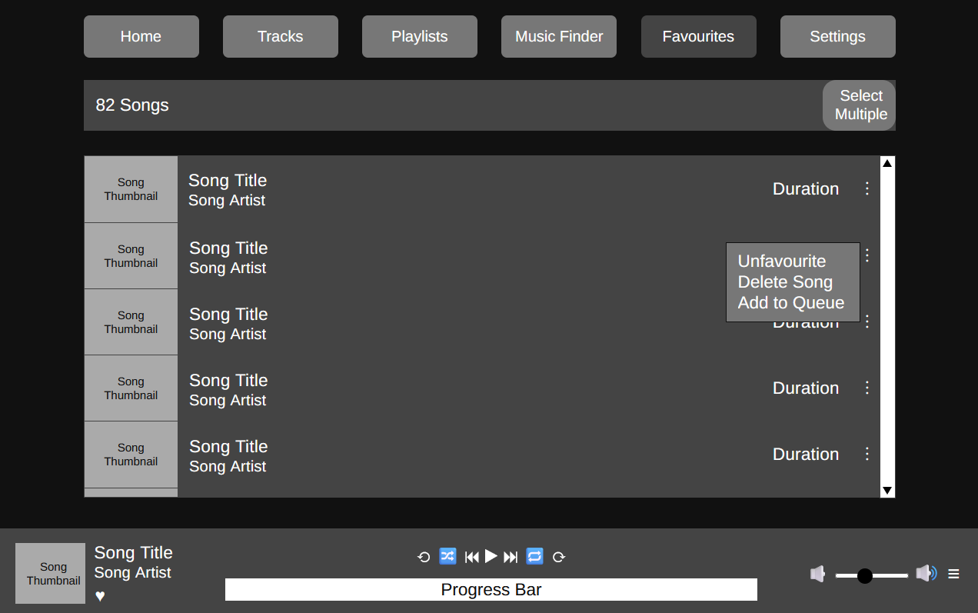

Settings
Development Test Plan
Test Num | Description and Justification | Input | Expected Output | Success
1
2
3
4
5

